INNOVATIVE TEACHING

INNOVATIVE TEACHING - MEDITATION CLASS FOR 1ST YEAR MSW STUDENTS
As a part of the subject, Personal and Professional Growth the students of 1st year MSW attended Meditation Class. Students were explained the significance of Meditation in understanding self and how it would help them keep up emotional health and gain professional growth.

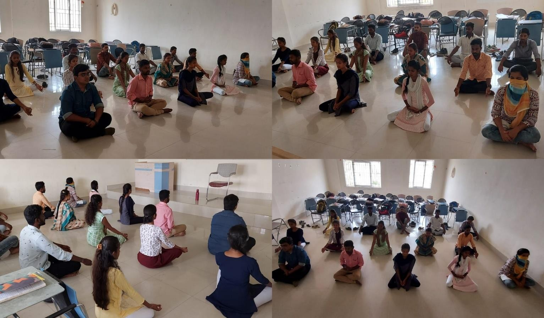

INNOVATIVE TEACHING - A PRACTICAL SESSION ON COUNSELING

As a part of curriculum, a practical session on Counseling - Mock Counseiling was conducted fir the 1st year MSW students to showcase the role and responsibilities of Counselors and also how and when they can adopt the skills and techniques in the process of counseling. It was good exposure to the students to understand how they need to interact with different clients.

